**Table of Contents**  
  
1 INTRODUCTION 3

1.1 Vision 4

1.2 Mission 4

1.3 Historical Background 4

1.4 Product/Service Offerings 5

1.4.1 Automobiles 5

1.4.1.1 Suzuki Alto 5

1.4.1.2 Suzuki Cultus 5

1.4.1.3 Suzuki Swift 6

1.4.1.4 Suzuki Wagon R 6

1.4.1.5 Suzuki Vitara 7

1.4.1.6 Suzuki Bolan 7

1.4.1.7 Suzuki Ravi 8

1.4.2 Motorcycles 9

1.4.2.1 GD110S 9

1.4.2.2 GR150 9

1.4.2.3 GSX-R600 9

1.4.3 Outboard Motors 10

1.4.4 Certified Used Cars 10

1.4.5 Service Campaigns 10

1.4.6 Customer Care 10

1.5 Objectives of Pak Suzuki 11

1.5.1 Customer Satisfaction 11

1.5.2 Innovation 11

1.5.3 Competitive Pricing 11

1.5.4 Business ethics 11

1.6 Performance Review 11

1.6.1 Sales 11

1.6.2 Market Share 12

1.6.3 Innovation 12

1.6.4 Customer Service 12

1.6.5 Current Status 12

2 External Analysis 14

2.1 External Factors (PESTLE) 14

2.1.1 Environmental 14

2.1.2 Political Factors 14

2.1.3 Economic Factors 14

2.1.3.1 Current and Projected Economic Growth 14

2.1.3.2 Inflation and Interest Rates: 15

2.1.4 Technological Factors: 15

2.1.5 Social Factors: 15

2.1.6 Legal Factors: 16

2.1.7 Environmental Factors: 16

2.1.8 Competitive Analysis 16

2.1.9 Identification of Competitors 17

2.1.9.1 Pak Suzuki Motor Company Limited: 17

2.1.9.2 Honda Atlas Cars Pakistan Limited: 17

2.1.9.3 Indus Motor Company Limited: 17

2.1.9.4 New Entrants 17

2.1.10 Impact of Competitors on Organization's Performance 17

2.1.10.1 Positive Impacts: 18

2.1.10.2 Negative Impacts: 18

2.1.10.3 Competitors' Strategic Moves and Actions 18

2.2 Market Mix (4ps) 20

2.2.1 Product strategy 20

2.2.2 Price strategy 20

2.2.3 Place strategy 21

2.2.4 Promotion strategy 21

3 Internal Analysis And BCG Matrix 22

3.1 Internal Factors 22

3.1.1 SWOT ANALYSIS: 22

3.1.1.1 Strength 22

3.1.1.2 Weakness 23

3.1.1.3 Opportunities 23

3.1.1.4 Threats 23

3.1.2 BCG MATRIX 24

3.1.2.1 Star 24

3.1.2.2 Question Mark 24

3.1.2.3 Cash Cow 25

3.1.2.4 Dog 25

4 Recommendation: 28

4.1 Industrial Analysis 28

4.2 Company Analysis 28

4.3 Customer service 28

4.4 Operations and Manufacturing 28

## INTRODUCTION

Pak Suzuki Motor Company Limited (PSMCL) is a Pakistani automobile company that is a subsidiary of Japanese automaker Suzuki. It is the Pakistani assembler and distributor of cars manufactured by Suzuki and its subsidiaries and foreign divisions. Currently, Pak Suzuki is the largest car assembler in Pakistan.

The firm was founded in September 1982 as a joint venture between the Government of Pakistan and Suzuki Motor Japan, formalizing the arrangement by which Awami Auto Ltd. had produced the Suzuki SS80 from 1982. Suzuki originally owned 25% of the stock and has gradually increased its holding; they now own 73.09%.

Figure ‎1‑1: Head Office Suzuki Pakistan (DSU-13, Pakistan Steel Industrial Estate Bin Qasim Town, Karachi)

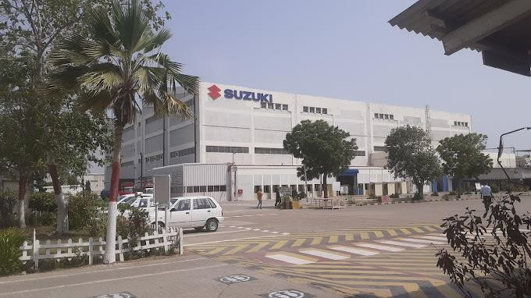

Pak Suzuki is engaged in progressive manufacturing, assembling, and marketing of Suzuki brand vehicles and motorcycles in Pakistan, under license from SMC-Japan. The company offers a wide range of vehicles, including cars, pickups, vans, 4x4s, and motorcycles, and related spare parts.

In terms of transportation, Pak Suzuki offers a range of vehicles that cater to different needs and preferences. The company has a wide range of dealerships and service centers across Pakistan.

However, the company has been facing operational troubles recently, with production activities being suspended due to a shortage of imported parts and accessories. The State Bank of Pakistan has imposed restrictions on the import of completely-knocked down (CKD) kits, which has caused inventory problems for the company. Despite these challenges, Pak Suzuki remains a significant player in the Pakistani automobile industry.

### Vision

“To be recognized as a leader organization that values customer need and provides motoring solution whit strong customer car.”

### Mission

* Develop product of superior value by focusing on the customer.
* Establish a refreshing and innovative company through teamwork.
* Strive for individual excellence through continuous improvement

### Historical Background

Pak Suzuki Motor Company Limited (PSMCL) was formed in August 1983 after a joint venture between the Government of Pakistan and Suzuki Motor Japan. The company started commercial production in January 1984 with the primary objective of progressive manufacturing, assembling, and marketing of cars, pickups, and motorcycles in Pakistan, under license from SMC-Japan.

Since then, Pak Suzuki has been a significant player in the Pakistani automobile industry, offering a wide range of vehicles, including cars, pickups, vans, 4x4s, and motorcycles, and related spare parts. The company has a wide range of dealerships and service centers across Pakistan.

Over the years, Pak Suzuki has faced various operational challenges, including production activities being suspended due to a shortage of imported parts and accessories. Despite these challenges, the company has remained committed to its mission of developing products of superior value by focusing on the customer and establishing a refreshing and innovative company through teamwork.

### Product/Service Offerings

Pak Suzuki Motor Company Limited offers a wide range of products and services in Pakistan, including:

#### Automobiles

Pak Suzuki offers a range of automobiles, including hatchbacks, sedans, SUVs, and pickups. Some of the popular models include following.

##### Suzuki Alto

The Suzuki Alto is a key car which has been produced by Suzuki since 1979. It is a small car that is popular in Pakistan due to its affordability and fuel efficiency. The latest model of the Alto is the ninth generation, which was introduced in 2019.

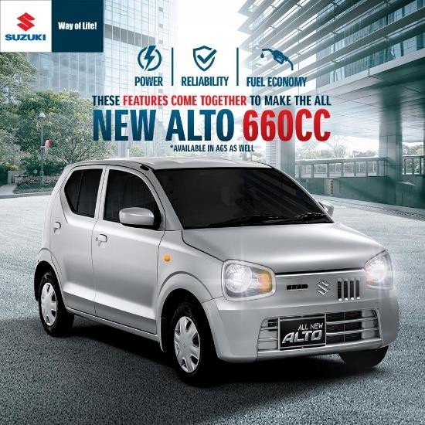

Figure ‎1‑2: Suzuki Alto

##### Suzuki Cultus

The Suzuki Cultus is a compact car that has been in production since 1983. It is a popular choice in Pakistan due to its affordability and practicality. The latest model of the Cultus was introduced in 2017.

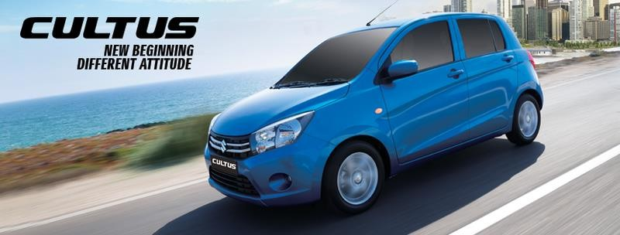

Figure ‎1‑3: Suzuki Cultus

##### Suzuki Swift

The Suzuki Swift is a subcompact car that has been in production since 2000. It is a popular choice in Pakistan due to its sporty design and fuel efficiency. The latest

model of the Swift was introduced in 2017.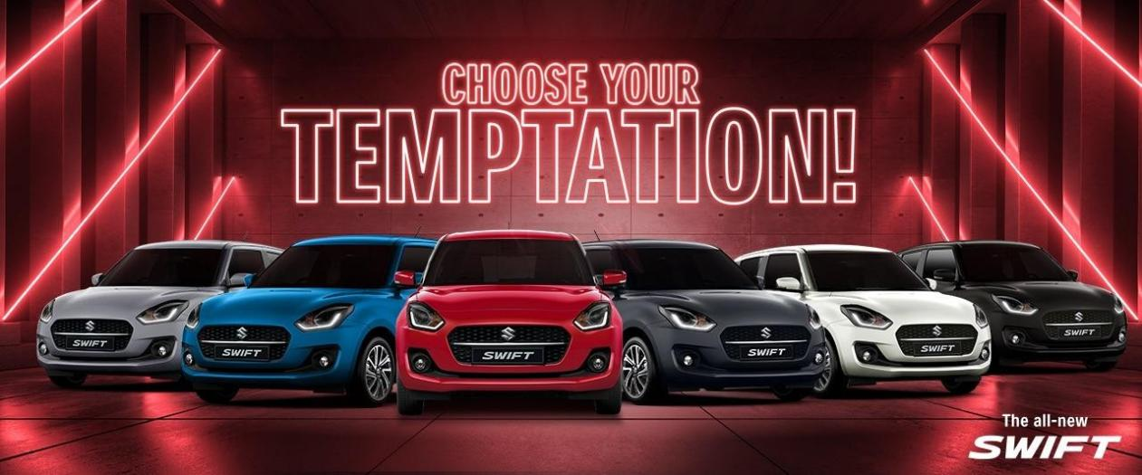

Figure ‎1‑4: Suzuki Swift

##### Suzuki Wagon R

The Suzuki Wagon R is a kei car that has been in production since 1993. It is a popular choice in Pakistan due to its spacious interior and fuel efficiency. The latest model of the Wagon R was introduced in 2018.

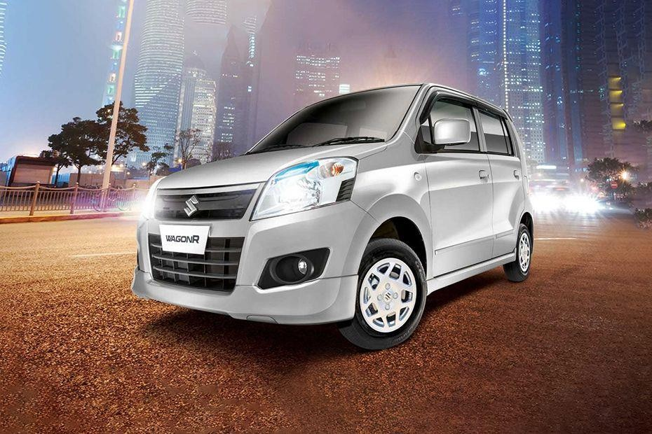

Figure ‎1‑5: Suzuki Wagon R

##### Suzuki Vitara

The Suzuki Vitara is a compact SUV that has been in production since 1988. It is a popular choice in Pakistan due to its rugged design and off-road capabilities. The

latest model of the Vitara was introduced in 2015.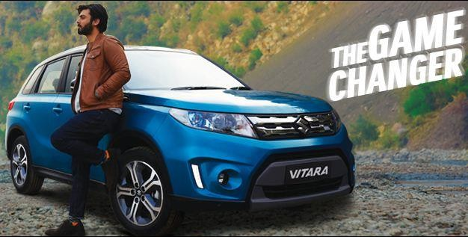

Figure ‎1‑6: Suzuki Vitara

##### Suzuki Bolan

The Suzuki Bolan is a minivan that has been in production since 1972. It is a popular choice in Pakistan for commercial purposes due to its affordability and practicality. The latest model of the Bolan was introduced in 2019.

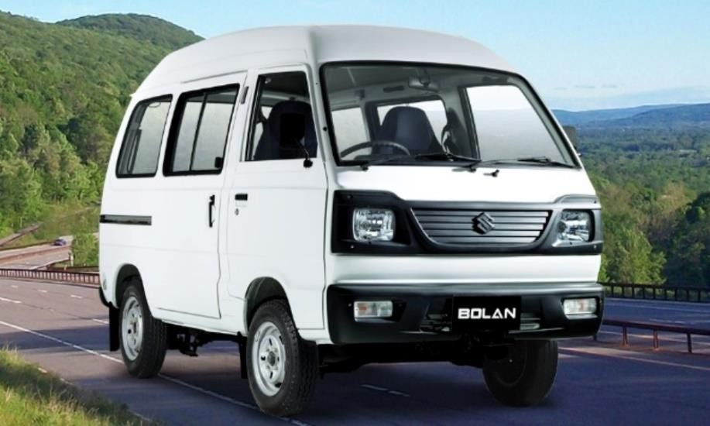

Figure ‎1‑7: Suzuki Bolan

##### Suzuki Ravi

The Suzuki Ravi is a pickup truck that has been in production since 1979. It is a popular choice in Pakistan for commercial purposes due to its affordability and practicality. The latest model of the Ravi was introduced in 2019.

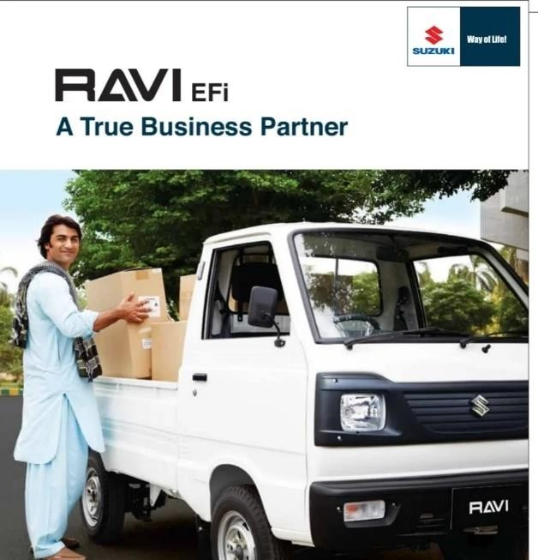

Figure ‎1‑8: Suzuki Ravi

#### Motorcycles

Pak Suzuki also offers a range of motorcycles, including:

##### GD110S

The Suzuki GD110S is a commuter motorcycle that is popular in Pakistan due to its fuel efficiency and affordability. It is powered by a 113cc engine and has a sleek design that makes it a popular choice among commuters.

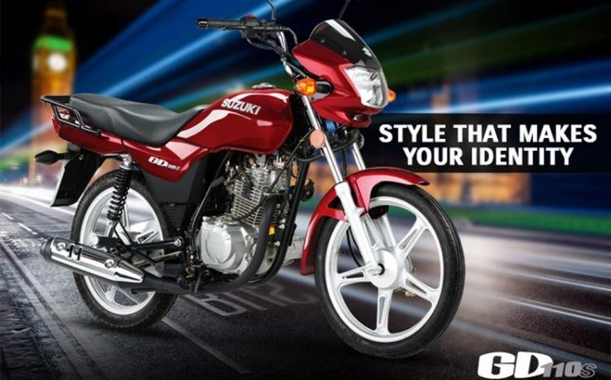

##### GR150

The Suzuki GR150 is a sporty motorcycle that is popular in Pakistan due to its performance and design. It is powered by a 150cc engine and has a sleek and aggressive design that makes it stand out on the road.

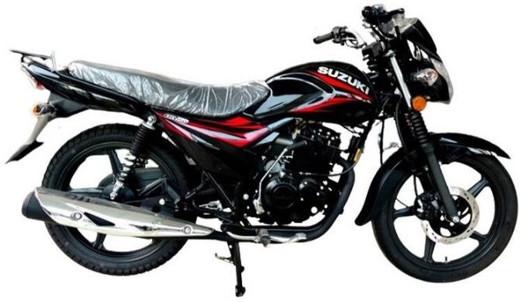

##### GSX-R600

The Suzuki GSX-R600 is a high-performance sports bike that is popular among enthusiasts in Pakistan. It is powered by a 599cc engine and has a lightweight design that makes it agile and responsive on the road.

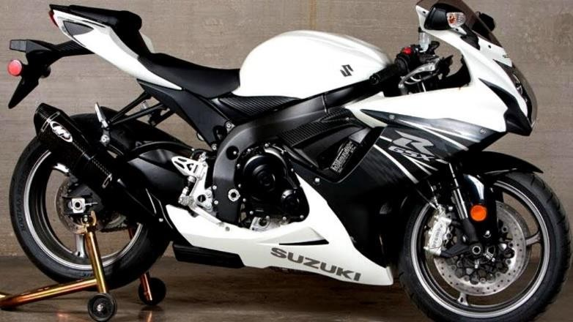

#### Outboard Motors

Pak Suzuki offers a range of outboard motors for boats and other watercraft.

#### Certified Used Cars

Pak Suzuki also offers certified used cars through its authorized dealerships.

#### Service Campaigns

Pak Suzuki regularly conducts service campaigns to ensure the safety and reliability of its vehicles.

#### Customer Care

Pak Suzuki is committed to providing excellent customer service and has a dedicated customer care team to assist customers with their queries and concerns.

### Objectives of Pak Suzuki

These are the objective of Pak Suzuki motors

#### Customer Satisfaction

Pak Suzuki motors aim to provide high quality products and services that exceed customer expectation. They also aim to prioritize customer safety and security to respond quickly to any quality related issues.

#### Innovation

Pak Suzuki motors aim to be innovation and refreshing though teamwork.They also aim to improve employees skills though training and participation.

#### Competitive Pricing

Pak Suzuki motors aim to provide automobile of international quality at competitive prices.

#### Business ethics

Pak Suzuki motors insists on integrity and honesty from its employee and believes in compliance with regulation obligation. They also believe in free and fir business practices and open competitive market.

### Performance Review

Suzuki Pakistan has been a significant player in the Pakistani automobile industry since its inception in 1983. Here is a brief overview of the company's performance in recent years:

#### Sales

Suzuki Pakistan has been one of the leading car manufacturers in Pakistan, with a wide range of vehicles that cater to different needs and preferences. According to the company's annual report for 2023, the company sold 104,000 units of automobiles and motorcycles in 2022.

#### Market Share

Suzuki Pakistan has a significant market share in the Pakistani automobile industry, with a range of popular models such as the Alto, Cultus, Swift, and Wagon R. According to a Glass door review, the company has an overall rating of 3.5 out of 5, based on over 57 reviews left anonymously by employees.

#### Innovation

Suzuki Pakistan has been introducing new models and features to its vehicles to keep up with changing customer demands. The company has also been participating in auto shows and events to showcase its latest offerings.

#### Customer Service

Suzuki Pakistan is committed to providing excellent customer service to its valued customers. The company offers a range of customer care services, including phone, SMS, email, and regional offices, to ensure that customers are satisfied with their products and services.

Suzuki Pakistan has been a significant player in the Pakistani automobile industry, offering a range of vehicles that cater to different needs and preferences. The company has a significant market share and is committed to providing excellent customer service to its valued customers.

#### Current Status

Suzuki Pakistan has been facing operational troubles recently, with production activities being suspended due to a shortage of imported parts and accessories. The State Bank of Pakistan has imposed restrictions on the import of completely-knocked down (CKD) kits, which has caused inventory problems for the company. As a result, the company has announced another series of non-production days (NPDs) for January 2023. The company will halt its production and assembly operations from January 16-20, 2023, due to the State Bank of Pakistan’s (SBP) restriction on automotive imports.

Despite these challenges, Suzuki Pakistan remains a significant player in the Pakistani automobile industry, with a market share of more than 60% as of December 2011. The company offers a range of automobiles and motorcycles, including hatchbacks, sedans, SUVs, and pickups. Suzuki Pakistan also offers customer care services, including phone, SMS, email, and regional offices, to ensure that customers are satisfied with their products and services.

Suzuki Pakistan is facing operational challenges due to the shortage of imported parts and accessories. However, the company remains a significant player in the Pakistani automobile industry, offering a range of vehicles and customer care services to its valued customers.

## External Analysis

### External Factors (PESTLE)

#### Environmental

Figure ‎2‑1: Environmental Factors

#### Political Factors

The Political stability plays very important role in the performance of any company. The company need to look at the political conditions of the countries in which it operates. The company need to follow policies related to automobile sector by the government. Government of the country want the global companies work are work to generate employment opportunities and boost the industrial growth, so the company must perform according to expectation of respective government.

#### Economic Factors

##### Current and Projected Economic Growth

Pakistan is facing a range of economic challenges, including high inflation, low growth, low foreign exchange reserves, and a range of other factors. The economic crisis has affected the demand for automobiles in Pakistan, making it more expensive to import parts and accessories, leading to a shortage of imported parts. The decline in the Large Scal Manufacturing (LSM) sector and a decrease in exports have adversely affected the economy.

##### Inflation and Interest Rates:

High inflation 4.10% and interest rates 12.89 % have affected the disposable income of consumers and businesses in Pakistan. This has affected the demand for automobiles in Pakistan, making it more expensive to import parts and accessories, leading to a shortage of imported parts.

#### Technological Factors:

Recent technological development in the industry should not be overlooked the company to compete with their competitors and also at same time provide more standardized products to its customers at low cost. The company have good number of profits and it invest heavy amount in research and development every year, which have helped it in sustaining profits in long term. The company have also invested in the green technologies to reduce its carbon emissions it results in the production processes. It has also developed many alternative fuels for its Multi Point Injection MPI engine.

The automobile industry is constantly evolving, with new technologies being developed to improve the production, distribution, and marketing of automobiles. Suzuki Pakistan needs to stay up-to-date with these advancements to remain competitive in the market.

#### Social Factors:

Suzuki have set up its welfare camps in country for taking care of people in that location. It has also opened its driving school in various countries to teach road behaviors to minimize the accident on the road. The culture of people now is changing as everyone want to have their personal car or bike, which have helped company in increasing its sales worldwide. Suzuki also sees customer safety as its top priority. Over the time it has manufactured very high standards car to satisfy its customer and also ensure their safety. It has also tried to increase the social value to its customers by continuously improving itself by seeing their customer requirements.

#### Legal Factors:

The company has over 50000 employees, so the company must follow the discrimination and health and safety laws to make them satisfied. Suzuki operates in more than 150 countries and must follow the legal requirements of the countries in which it operates. Laws are enacted by the countries to ensure safety standards and also regulate the price of the particular product in the country. The company has always tried to follow these legal factors of various countries to satisfy its various stakeholders. The company has developed software to monitor compliances activities going throughout the company.

#### Environmental Factors:

These factors are gaining great importance in today’s world as customers are becoming more sophisticated now and they perceived the company image on the basis of what additional the company is doing to control the carbon emission and reduce the pollution it causes.

Suzuki has followed laws related to emission of fuels and safety. The company uses many parts in its production process which can be recycled and reused. It has launched hybrid cars which causes less pollution and are economical also.it have also taken various environmental friendly initiatives to teach people about the importance of having clean environment and ways to tackle the problem of climate change.

#### Competitive Analysis

The entrance of new car makers, such as KIA, MG, and Hyundai, has changed the industry dynamics in Pakistan. The evolution of new competition is yet to be seen. Here are some relevant insights on competitive analysis in the automobile industry in Pakistan:

The key players in the Pakistan automotive market include Pak Suzuki Motor Company Limited, Honda Atlas Cars Pakistan Limited, and Indus Motor Company Limited.

Suzuki Pakistan needs to be aware of the competitive landscape in the automobile industry in Pakistan and adapt its strategies accordingly to remain competitive in the market. The company needs to continue to invest in new technologies to improve its business objectives and performance in the long run. The entrance of new car makers is an important trend that could affect Suzuki Pakistan's market share and financial performance in the long run. The company needs to find ways to address these challenges to sustain its operations in the long run.

#### Identification of Competitors

Here are the competitors of Suzuki Pakistan in the automobile industry in Pakistan:

##### Pak Suzuki Motor Company Limited:

Pak Suzuki Motor Company Limited is one of the key players in the Pakistan automotive market and has the highest market share among the selected brands in the automotive or automobile (cars) industry in Pakistan.

##### Honda Atlas Cars Pakistan Limited:

Honda Atlas Cars Pakistan Limited is another key player in the Pakistan automotive market.

##### Indus Motor Company Limited:

Indus Motor Company Limited is another key player in the Pakistan automotive market.

##### New Entrants

The entrance of new car makers, such as KIA, MG, Hyundai, Changan-Master Motors, Proton-Al Haj, and Regal Motors-DFSK & Prince, has changed the industry dynamics in Pakistan. The evolution of new competition is yet to be seen.

Suzuki Pakistan needs to be aware of its competitors in the automobile industry in Pakistan and adapt its strategies accordingly to remain competitive in the market. The company needs to find ways to address the challenges posed by new entrants to sustain its operations in the long run.

#### Impact of Competitors on Organization's Performance

The impact of competitors on Suzuki Pakistan's performance in the automobile industry in Pakistan can be significant. Here are some potential impacts:

##### Positive Impacts:

* + - * Competition can drive innovation and encourage companies to invest in new technologies to improve their business objectives and performance in the long run.
      * Competition can lead to better quality products and services, which can benefit consumers.

##### Negative Impacts:

* + - * Increased competition can lead to a decrease in market share and financial performance for Suzuki Pakistan.
      * New entrants offering new models and features that meet changing consumer preferences could affect Suzuki Pakistan's market share and financial performance in the long run.
      * The impact of new technology on business objectives should be conducted at a wider level to ensure that the company is not left behind in the industry.

Suzuki Pakistan needs to be aware of the potential impacts of competitors on its performance in the automobile industry in Pakistan and adapt its strategies accordingly to remain competitive in the market. The company needs to find ways to address the challenges posed by new entrants and invest in new technologies to improve its business objectives and performance in the long run.

##### Competitors' Strategic Moves and Actions

Here are some strategic moves and actions taken by Suzuki Pakistan's competitors in the automobile industry in Pakistan:

* + - * Pak Suzuki Motor Company Limited: Pak Suzuki Motor Company Limited has been maximizing its market share by producing more cars per year and developing more efficient and innovative engines that give it a comparative advantage. The company has been investing in new technologies to improve its business objectives and performance in the long run.
      * Honda Atlas Cars Pakistan Limited: Honda Atlas Cars Pakistan Limited is another key player in the Pakistan automotive market. The company has been competing with Pak Suzuki Motor Company Limited and Indus Motor Company Limited for market share in the automobile industry in Pakistan.
      * Indus Motor Company Limited: Indus Motor Company Limited is another key player in the Pakistan automotive market. The company has been competing with Pak Suzuki Motor Company Limited and Honda Atlas Cars Pakistan Limited for market share in the automobile industry in Pakistan.
      * New Entrants: The new entrants, such as KIA, MG, Hyundai, Changan-Master Motors, Proton-Al Haj, and Regal Motors-DFSK & Prince, have been changing the industry dynamics in Pakistan. These new entrants have been offering new models and features that meet changing consumer preferences, which could affect Suzuki Pakistan's market share and financial performance in the long run.

Suzuki Pakistan needs to be aware of its competitors' strategic moves and actions in the automobile industry in Pakistan and adapt its strategies accordingly to remain competitive in the market. The company needs to find ways to address the challenges posed by new entrants and invest in new technologies to improve its business objectives and performance in the long run.

### Market Mix (4ps)

We are use the 4ps in market mix stratagems.

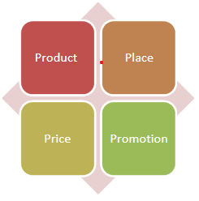

#### Product strategy

Introduce a close range of vehicles catering to different segments, including cars and motorcycles to meet varying customer needs and preferences.The pak Suzuki motors are focus on product innovation by incorporating advanced features such as hybrid technology, smart connectivity, Electric Technology and safety enhancements to stay competitive in the market .

#### Price strategy

Implement a competitive pricing strategy that reflects the value proposition of Suzuki vehicles while remaining attractive to target customers. Offer flexible pricing options, such as installment plans and promotional discounts, to enhance affordability and stimulate sales.

#### Place strategy

Expand the dealership network to reach a wider geographic area and ensure convenient access for customers across different regions. Strengthen online sales channels and digital platforms to facilitate seamless vehicle purchases and provide virtual showroom experiences.

#### Promotion strategy

Launch integrated marketing campaigns across multiple channels, including television, digital media, social platforms, and print media, to create brand awareness and generate customer interest. Collaborate with influencers, automotive bloggers, and media outlets to showcase Suzuki's product features, customer testimonials, and promotional offers effectively.

## Internal Analysis And BCG Matrix

### Internal Factors

#### SWOT ANALYSIS:

The SWOT analysis of key players in the Pakistan automotive market provides insights into their strengths, weaknesses, opportunities, and threats.

##### Strength

Pak Suzuki motor has highest market shear due to low price vehicles as they are assembled locally. The target segment of Pak Suzuki is middle class and growing middle class. The first vehicle that most people buy in Pakistan is Suzuki. Advantages of buying Suzuki vehicle are increase in demand, It is economical ,it has goog resale value the spare parts are easily available at lower rate and better fuel efficiency as compared to other vehicles.

Suzuki provide one window solution for all auto related problems under one roof. Pak Suzuki along with selling vehicles also provide various other auto related services. These services are Suzuki finance, insurance, certified used car and Suzuki extended Warranty.

##### Weakness

Pak Suzuki locally assembles vehicle at dissembling plant using imported and locally manufactured parts. The scarcity of locally available raw ,aterial and less production of most parts at local level resulet in increase of cost. Over the year pak Suzuki hass filed of essemble and manufacture a completle vehicale at local palant.

The Pak Suzuki has one of the largest distribution networks in Pakistan still it is not able to from dealership network in urban and rural areas.

There is also no international standers training institution of technical educational available for its employee and its send most of employees abroad to under certain training.

##### Opportunities

Automobile market in Pakistan is full of opportunities and Pak Suzuki has grabbed this opportunity rights. Through pak Suzuki hold maximum shear in the market still its has vast areas to penetrate and explore.

The growth middle class and increasing purchasing power has led to an increase in demand for car. Pak Suzuki has an opportunity to grab this growth demand by positioning its products in context to consumer demand.

Introduction and innovation in product line is a vast area to explore for pak Suzuki.

Producing Luxury vehicle such as “KIZASHII” has made Pak Suzuki to penetrate into market of Luxury car. The pak Suzuki motors are already produced the Eco-friendly vehicles and it will to turn its few products into Hybrid car. The market are provided the opportunities auto mobile vehicle charge able car.

##### Threats

Despite being the leader and large shareholder of Pakistan automobile industry. Pak Suzuki is also facing several threats for local and international competitors like Toyota and Honda as well as import of used Japanese cars are a serious challenge for Pak Suzuki.

The changing political are also badly affecting pak Suzuki. Devaluation of PAK Rupee against US Dollar and other currency are use in international tread the unstable economy condition are causing serious threats to pak Suzuki. Inflation and smuggling of spear parts are a result of bad governance and mismanagement of government which is a threat to auto sector.

The over security and political situation in pakistan is also less favorable for automobile company such as Pak Suzuki.

#### BCG MATRIX

|  |  |  |  |
| --- | --- | --- | --- |
| Star   |  | | --- | | BOLAN | | |  | | --- | | SWIFT |   Question Mark |
| |  | | --- | | CULTUS |  |  | | --- | | MEHRAN |  |  | | --- | | ALTO |   Cash Cows | |  | | --- | | APV |  |  | | --- | | LIANA |   Dogs |

High

Market Growth

Low

High Market Share Low

##### Star

From BCG matrix we can analyze that PSMC has covered high market shares. Market growth is high in terms of BOLAN.

##### Question Mark

PSMC has introduced SWIFT to counter VITZ (TOYOTA). After introduction, it gained high market shares but remained unsuccessful to grow in terms of market share.

##### Cash Cow

MEHRAN, CULTUS and ALTO have generated high income to the company. Although they have low market growth but share in market is very high.

##### Dog

LIANA and APV scored Dog position in BCG matrix because of low market demand, high competition and high prices of Units.

EXTERNAL FACTOR EVALUATION MATRIX (EFE)

|  |  |  |  |  |
| --- | --- | --- | --- | --- |
|  | OPPORTUNITIES | Weight | Ratings | Weighted Score |
| 1. | Increasing Demand for Cars | 0.15 | 4 | 0.60 |
| 2. | Efficient EFI Engines | 0.10 | 3 | 0.30 |
| 3. | Large Market to operate | 0.10 | 3 | 0.30 |
| 4. | Global spare parts market | 0.05 | 2 | 0.10 |
| 5. | Small size CNG Cylinders | 0.12 | 3 | 0.36 |
|  | THREATS |  |  |  |
| 1. | Tough Competitors like Toyota and Honda | 0.14 | 2 | 0.28 |
| 2. | Inflation Rate | 0.08 | 3 | 0.24 |
| 3. | Heavy Taxes | 0.08 | 3 | 0.24 |
| 4. | Cheaper Imported Cars | 0.10 | 4 | 0.40 |
| 5. | Increase in fuel Prices | 0.08 | 2 | 0.16 |
|  |  |  |  |  |
|  | Total Weighted Score | 1.0 |  | 2.98 |
|  |  |  |  |  |

Ratings:

1-Poor 3-Above Average

2-Below Average 4-Superior

The total weighted score of 2.98 shows that company is responding above average to its external factors. They are trying to grab maximum opportunities available there and avoiding the threats to their best.

Justification of Ratings

1. The company is producing the maximum number of cars in compare with other competitiors and therefore grabbing the opportunity to meet the increasing demand.
2. Pak Suzuki has introduced is never introduced before in below 1300cc cars.
3. The dealer network of Pak Suzuki is almost all around the country which help them to maximum their sales and reach in every in every corner of the country.
4. In new CNG fitted cars, the Suzuki is introducing new compact CNG cylinders which take less space and are lighter than their equivalent availabale in the market.
5. The major threat Suzuki Company could have is from Toyota and Honda, as Suzuki is still unable to meet them in 1300cc and above category of cars. The new product SWIFT is not giving the respond which was expected.

INTERNAL FACTOR EVALUATION MATRIX (IFE)

|  |  |  |  |  |
| --- | --- | --- | --- | --- |
|  | STRENGTHS | Weight | Ratings | Weighted Score |
| 1. | Highest Market Share | 0.20 | 4 | 0.80 |
| 2. | Low Price Vehicles | 0.10 | 4 | 0.40 |
| 3. | Large Distribution Channels | 0.12 | 4 | 0.48 |
| 4. | Easy availability of spare parts | 0.08 | 4 | 0.32 |
| 5. | Highly innovative and deep product line | 0.12 | 4 | 0.48 |
|  | WEAKNESSES |  |  |  |
| 1. | Raw Material | 0.08 | 2 | 0.16 |
| 2. | Lack of coordination and linkage with Govt.bodies | 0.05 | 2 | 0.10 |
| 3. | Less focus on Looks and design | 0.10 | 1 | 0.10 |
| 4. | Less Technical Training Institutes | 0.05 | 1 | 0.05 |
| 5. | Less distribution channels in sub urban areas | 0.10 | 1 | 0.10 |
|  |  |  |  |  |
|  | Total Weighted Score | 1.0 |  | 2.99 |
|  |  |  |  |  |

Rartings :

1-Major Weakness 3-Minor Strength

2-Minor Weakness 4-Major Strength

The score 2.99 shows that company has solid internal position, its strengths are overcoming the weaknesses.

Justification of Ratings:

1. Pak Suzuki Motor Company has large market share herein and also the largest producers of cars which is a major strength.
2. Their prices are very affordable in the same quality that is another major strength.
3. The large distribution channel is another major strength which helps them to achieve their desired sales targets.
4. The innovation is another key strength of Pak Suzuki and the example is new Suzuki SWIFT.
5. The spare parts availability is a critical issue which cars, Suzuki has comparative advantage In spare parts availability as most of them are being manufactured in Pakistan.
6. The major weakness which I felt is the non-availability of skiled engineers and workforce. And the reason behind is lack of technical institutes under their banner.
7. They should also focus on sub-urban areas like Southern Punjab and Interior Sind which their distribution network.

## Recommendation:

Pak Suzuki motor is a leading automatic manufacturer in Pakistan .this company are offering a range of vehicle including cars and motorcycles. The recommendation for Pak Suzuki motors

### Industrial Analysis

Analyses the Pakistani automotive market are including market size, trend, competition and consumer performances. Assess Pak Suzuki market shear and position within the industry.

Identify the key challenges and opportunities for Pak Suzuki in the current market.

### Company Analysis

The Pak Suzuki motors are analysis the organizational Structure and management team. They are study its product portfolio its strengths and weaknesses. To analysis the financial performance likes Revenue, profitability and market capitalization.

### Customer service

Pak Suzuki motor are analysis the effectiveness of its distribution network after sales services. They are improve its marketing and sales strategies.

### Operations and Manufacturing

Investigate the manufacturing processes and facilities. To analysis the supply chain management and logistics. Assess the company commitment to quality control and customer satisfaction.